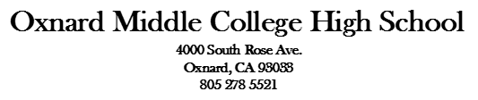

Title I Meeting/Junta del Titulo I Agenda
October 5, 2021

1.0 Welcome/Bienvenida
Sign in/ Lista de asistencia

2.0 Approval of Agenda/Minutes/ Aprovacion de Agenda y minutas

3.0 Title I Presentation/Presentación del programa de Titulo I

4.0 Training: Rationale for School Site Council (SSC) Meetings/Capacitación:
fundamento de las reuniones del consejo del plantel escolar (SSC)

4.1 Parents Groups -- Roles and Responsibilities/ Grupos de padres:
funciones y responsabilidades
4.2 Uniform Complaint Procedures/Procedimientos uniformes de quejas

5.0 Interest Form to serve in SSC or ELAC/ Forma de interes en servir en Consejo
Escolar o ELAC

6.0 Review Single Plan for Student Achievement (SPSA)/Revisar el Plan Unico para el Aprovechamiento del Estudiante (SPSA)

7.0 Advice from ELAC/Consejos de ELAC

8.0 WASC

9.0 Other Items/Otros elementos

10.0 Closing/Clausura

School Site Council Meetings: ELAC Meetings:
October 5, 2021 October 5, 2021 November 9, 2021 February 15, 2022
February 15, 2022 April 5, 2022
April 5, 2022 May 17, 2022
May 17, 2022

